Week of : October 5, 2020 | Grade Level: Kindergarten
PYP Unit and Central Idea: Who We Are- Roles and responsibilities help us make connections.
Prioritized Standards Addressed This Week:
Math
MGSEK.CC.1 Count to 100 by ones and by tens.
MGSEK.CC.4 Understand the relationship between numbers and quantities; connect counting to cardinality.
MGSEK.CC.2 Count forward beginning from a given number within the known sequence (instead of having to begin at 1).
Reading/ ELA ELAGSEKRL10: ELAGSEKRF3: Know and apply grade-level phonics and word analysis skills in decoding words. ELAGSEKRL1: With prompting and support, ask and answer questions about key details in a text

Science/ Social Studies SSKE1 Describe the work that people do such as: police officer, fire fighter, soldier, mail carrier, farmer, doctor, teacher, etc. SSKCG1 Demonstrate an understanding of good citizenship. a. Explain how rules are made and why. b. Explain why rules should be followed.

Asterisk & Highlighted items will be graded
Lessons Highlighted in blue will be Synchronous Lessons (Live in Teams)
Synchronous – Live Asynchronous – Not live

 | MONDAY | TUESDAY | WEDNESDAY | THURSDAY | FRIDAY

Student Login/  Morning Meeting (SEL)  8:15 a.m. | Focus Lessons  Synchronous- Share Screen  Heards Ferry Live  Morning Meeting | Focus Lessons  Synchronous- Share Screen  Heards Ferry Live  Morning Meeting | Focus Lessons  Synchronous- Share Screen  Heards Ferry Live | Focus Lessons  Synchronous- Share Screen  Heards Ferry Live  Morning Meeting | Focus Lessons  Synchronous- Share Screen  Heards Ferry Live  Morning Meeting  Announce student of the week for next week
Math  8:30 a.m. | Synchronous- Share Screen  Counting strategy  Move/touch and count/count out loud | Synchronous- Share Screen  Warm-Up-Count by 10’s to 100 and count to 40 by 1’s | No synchronous component today. Find the activity below and complete the assignment.  Representing numbers in different ways | Synchronous- Share Screen  Warm-Up-Count by 10’s to 100 and count to 40 by 1’s | Synchronous- Share Screen  Warm-Up-Count by 10’s to 100 and count to 40 by 1’s
 | Student Independent Practice  In Seesaw, find the activity below. Watch the instructional video and complete the assignment.  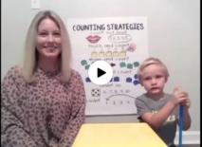  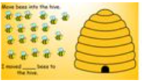 | Student Independent Practice  In Seesaw, watch the video and complete the activity below.  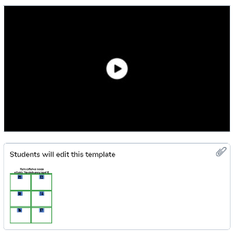 | Student Independent Practice  In Seesaw, find the activity below. Watch the instructional video and complete the assignment.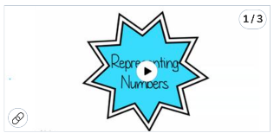 | Student Independent Practice  On Seesaw,  Listen to the story, “The Very Hungry Caterpillar” and complete the activity.  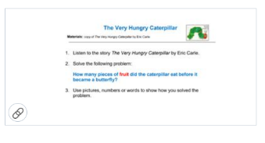 | Student Independent Practice  In Seesaw, watch the video and complete the activity below.  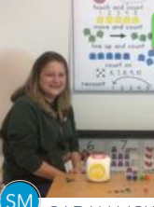
Specials  9:10am | PE with Coach K  Specials will now be conducted in Teams instead of Seesaw. When you join your specials team, find and click on the channel with our day and class name on it.  If you have any assignments to turn in, you will continue to submit them via Seesaw. | PE with Coach K  Specials will now be conducted in Teams instead of Seesaw. When you join your specials team, find and click on the channel with our day and class name on it. | Art with Mrs. Strom  Specials will now be conducted in Teams instead of Seesaw. When you join your specials team, find and click on the channel with our day and class name on it. | No specials day- Go Noodle, Iready reading and/or math, catch up on/begin independent practice, EPIC books, etc. | Music with Mrs. Badovinac  Specials will now be conducted in Teams instead of Seesaw. When you join your specials team, find and click on the channel with our day and class name on it.  If you have any assignments to turn in, you will continue to submit them via Seesaw.
Reading/ELA  11:15 a.m. | Reading groups will be conducted with the students in person | Reading groups will be conducted with the students in person | No synchronous component today. Find the activity below and complete the assignment. | Reading groups will be conducted with the students in person | Reading groups will be conducted with the students in person
 | Student Independent Practice  Reading  Log in to RAZ Kids Read the nursery rhyme “Jack and Jill” and complete the following activity on Seesaw.  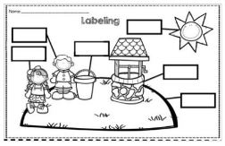  Phonics  Letter P  Watch the video lesson on Seesaw. Then, find two items around the house that begin with the letter P and take a photo of them. | Student Independent Practice  Reading  Log in to EPIC books. Listen to the old favorite storybook, “The Little Red Hen.” Then, complete the following activity on Seesaw.  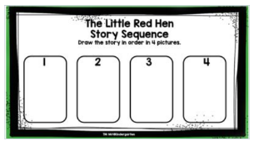  Phonics  Letter P  Watch the video lesson on Seesaw. Then, on a piece of paper, write the word for each picture: pig, pad, pop. Stretch out the sounds and write the letter for each sound. Then, take a picture of your work and submit it to Seesaw.  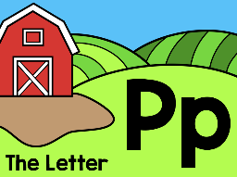 | Student Independent Practice  Student Independent Practice  Writing  Show and Tell Lesson 1  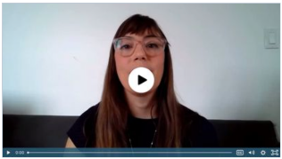  Phonics  Digraph Ch  Watch the video lesson on the digraph ch. Then, circle the correct spelling of each word. | Student Independent Practice  Writing  In Seesaw, watch the instructional video and complete the assignment. 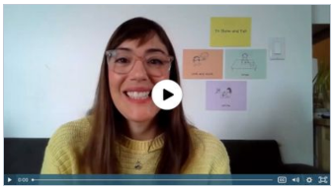  Phonics  Digraph Ch  Watch the video lesson on Seesaw. Then, say the word for each picture. Color in the circle for ‘start’ if you hear the ch sound at the beginning of the word. Color in the circle for ‘end’ if you hear the ch sound at the end of the word. | Student Independent Practice  Phonics  Consonant, Vowel, Consonant (CVC) Words  Watch the video on Seesaw. Then, drag the vowels to create your own CVC words and then record yourself reading them.  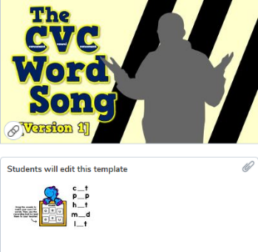
Social Studies /Science  11:45 a.m. | Focused Lesson  No synchronous component. Please complete the activity below. | Focused Lesson  No synchronous component. Please complete the activity below. | Focused Lesson  No synchronous component. Please complete the activity below. | Focused Lesson  No synchronous component. Please complete the activity below. | Focused Lesson  No synchronous component. Please complete the activity below.
 | Student Independent Practice  Complete the blueprint of your community helper building on Seesaw and submit.  Due Friday October 9th and submit on Seesaw. Bring your completed project to school on Wednesday October 14^{th.} | Student Independent Practice  Begin working on your community building. Please see newsletter attached to this week’s email.  Due Friday October 9th and submit on Seesaw. Bring your completed project to school on Wednesday October 14^{th.} | Student Independent Practice  Continue working on your community building. Please see newsletter attached to this week’s email.  Due Friday October 9th and submit on Seesaw. Bring your completed project to school on Wednesday October 14^{th.} | Student Independent Practice  Continue working on your community building. Please see newsletter attached to this week’s email.  Due Friday October 9th and submit on Seesaw. Bring your completed project to school on Wednesday October 14^{th.} | Student Independent Practice  Finish working on your community building. Please see newsletter attached to this week’s email.  Due Friday October 9th and submit on Seesaw. Bring your completed project to school on Wednesday October 14^{th.}
Independent Work Time  12:00-12:45 | Finish any Seesaw work  iReady Math | Finish any Seesaw work  iReady reading | Finish any Seesaw work  iReady math | Finish any Seesaw work  iReady reading | Finish any Seesaw work  iReady math
Due Dates | All Independent practice activities will be due Friday October 23rd. | All Independent practice activities will be due Friday October 23rd. | All Independent practice activities will be due Friday October 23rd. | All Independent practice activities will be due Friday October 23rd. | All Independent practice activities will be due Friday October 23rd.

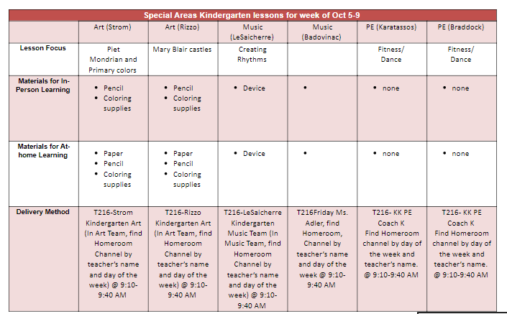
Badovinac: Lesson topic: Creating Rhythm
Material needed: none

