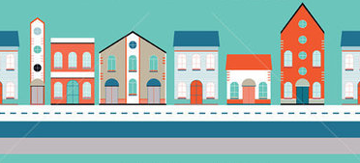
Dear Parents,
Our current IB unit in Social Studies is called “Who We Are.” Our lines of inquiry for this unit are “What is a community?”, “What is a community helper?”, and “What role do I play in a community?”
The students will be working on a culminating project as we near the end of this unit. The project they will be working on is a 3D map of a new community that we will create as a class.
1. Talk with your child about the different buildings that are found in a community i.e. Post Office, Grocery Store, and Police Station and decide which building your student wants to create.
2. Fill out the “blue print” of your building on Seesaw on Monday, October 5.
3. Collect objects from home to help create their building, such as cotton balls, cloth, small boxes, toilet paper rolls, etc. Use these items to build your 3D building during social studies this week and submit a picture to Seesaw Friday October 9th.
4. Bring your building to school on Wednesday, October 14th.
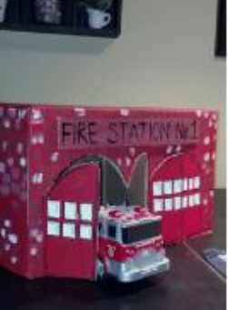
Thank you,
The Kindergarten Team
