Dear parents,

In accordance with the kindergarten social studies standard SSKG1 “I can celebrate cultural differences between my family and other families” and SSKH2 “The students will identify important symbols and explain their meaning,” we are asking our students to participate in a special project celebrating their family traditions. This project will require students to create a 3d model of a holiday symbol representing their winter holiday traditions.

Students can collect, draw, paint, build, and use pictures to create this model. For example, students can use paper towel rolls or Legos to create their menorah for Hanukkah. They can then paste pictures of their traditions to each candle or flame. A dreidel could even be made with a tradition on each side. For Christmas, students can make a tree with recycled materials with each ornament on the tree representing a holiday tradition such as a picture of your visit to see Santa, a present, a cookie, etc. Some other holiday symbols you could create are the Kinara for Kwanzaa and a Diya for Diwali. These are just suggestions. Any symbol that represents your family is welcomed as a part of this project. Be creative!  We just want to see how you celebrate and continue on family traditions!

We will then be having a festival of traditions in which students will travel to other classes to view everyone’s 3d holiday traditions project. Before presenting to classes, we ask that students practice at home describing each tradition on their 3d project. Please see the rubric for specifics. This project will be due on December 20th.

This project can take the place of any night’s homework.

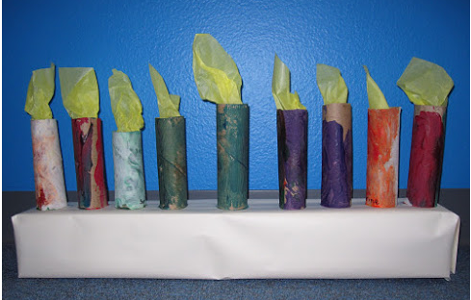Thank you!

The Kindergarten Team

[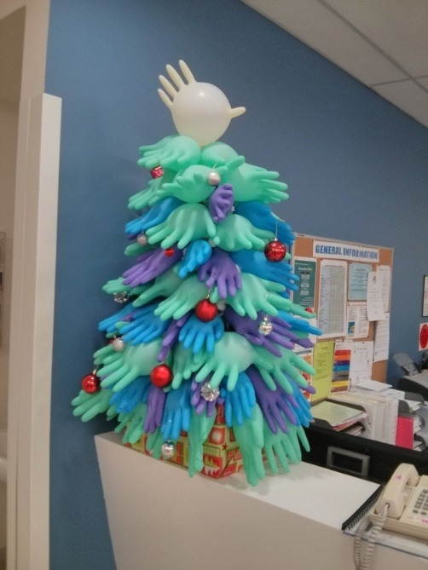](http://www.google.com/url?sa=i&rct=j&q=&esrc=s&source=images&cd=&cad=rja&uact=8&ved=0ahUKEwidl53jwrvJAhXJOz4KHfCABX0QjRwIBw&url=http://www.greenmoxie.com/15-alternative-recycled-and-upcycled-christmas-trees/&psig=AFQjCNF3-7cDfy7-xCm-ufi_F5RTANEuvA&ust=1449088798568095)[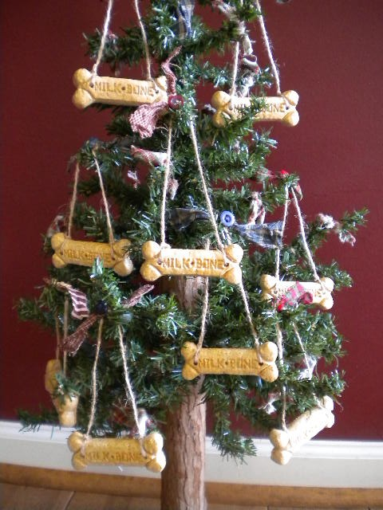](http://www.google.com/url?sa=i&rct=j&q=&esrc=s&source=images&cd=&cad=rja&uact=8&ved=0ahUKEwiutcyNw7vJAhWDrD4KHYLlBSkQjRwIBw&url=http://www.babble.com/pets/20-ways-to-include-pets-in-your-holiday-decor/&psig=AFQjCNF3-7cDfy7-xCm-ufi_F5RTANEuvA&ust=1449088798568095)

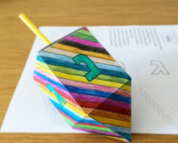[](https://www.google.com/imgres?imgurl=http://dekhnews.com/wp-content/uploads/2015/11/Special-Happy-Diwali-Whatsapp-Status-Wishes.jpg&imgrefurl=http://www.dekhnews.com/special-happy-diwali-whatsapp-status-wishes-sms-greetings-fb-dp-images-photos-2015/&h=400&w=700&tbnid=fkCZSaT2e-U5GM:&docid=O9LMXImqnW_iSM&ei=XgheVo3WGIGq-QGkjqk4&tbm=isch&ved=0ahUKEwiN_cmZxbvJAhUBVT4KHSRHCgcQMwgmKAowCg)