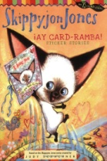
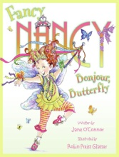
Storybook Character Day
Wednesday, October 31st, 2018
On Wednesday, October 31st, we will be celebrating our favorite storybook characters! This month, each student will be preparing a presentation in class to share. Here’s what you need to do at home:
- Select a book to read together several times and then discuss the characters in it. Have your child bring this book to class by Monday, October 15th. We will be using it from 10/15- 10/31.
- Select a character from the book and plan a costume to wear on October 31st. The costume does not have to be elaborate and can be assembled from items found around the house. (Reminder: no masks or weapons of any type!)
- In class, students will work on a presentation about the book – the presentations may vary from class to class. The presentation will include:
  - The title of the book
  - The name of the author
  - The name of the illustrator
  - The character the students have chosen to dress as and how they are like them and different from them.

We can’t wait to see what you come up with!

Thank you,
The K Team

